Final Assessment-Alternative Assessment
Semester | 202520 | Division | CIS
Assessment title in Syllabus | Final_Project_Portfolio | Program | Bachelor of Information Technology/ Bachelor of Information Systems
Course Code | CDS 2413
Course Title | INTRODUCTION TO DATA SCIENCE
Course Instructor |  | CRN
Assessment | Project Deliverable 2 – Machine Learning Model Report | Submission Date | Week 13
Student Declaration:
Academic Integrity Statement
In accordance with the HCT Academic Integrity Policy
• Students are required to refrain from all forms of academic integrity breaches as defined and explained by HCT.
• A student found guilty of having committed acts of academic integrity breach(es) will be subject to the relevant sanctions as outlined by HCT.
إفادة النزاهة الأكاديمية
وفقًا لسياسة كليات التقنية العليا للنزاهة الأكاديمية
• على الطلبة الإلتزام بلوائح وقواعد النزاهة الأكاديمية، كما هو مبيّن وموضح في السياسات والإجراءات الخاصة بكليات التقنية العليا.
• في حالة ارتكاب الطالب أي شكل من أشكال الإخلال بالنزاهة الأكاديمية، سيتعرض الى العقوبات الموضحة في السياسات ذات الصلة.
This assignment is entirely my/our own work except where I have duly acknowledged other sources in the text and listed those sources at the end of the assignment. I have not previously submitted this work to the HCT, or any other entity. I understand that I may be orally examined on my submission.

Student HCT ID(s): | H00596208 | H00 | H00 | H00
Student Name(s): | Maryam Musabbeh
Student Signature
Chatbot (e.g. ChatGPT) statement
This submission allows you to use AI generated tools, but the prompt used must be stated and the response must be in red font. Include References to ChatGPT.

Instructions

Remove instructions and hints from the template before submitting the final report to BBLearn.

CLO3: Machine Learning Model (25 Points)

Preprocessing(5 Points)

Data Collection (1 Point)

The dataset was firstly imported using the Python libraries pandas and numpy, which are remarkably efficient tools for data manipulation and numerical operations. The dataset was saved in the CSV format and read using pandas. read_csv(), which is a structured way of having access to all the variables.

The dependent variable was identified as FinalGrade, as it represents the academic outcome that the model aims to predict. All other relevant variables were treated as independent variables, including AttendanceRate, StudyHoursPerWeek, PreviousGrade, ExtracurricularActivities, ParentalSupport, Gender, and Online Classes Taken, as they represent factors that might be influencing student performance.

In this context attributes such as StudentID and Name, were considered irrelevant and therefore removed, since they are merely identifiers and thus contribute no meaningful predictive information. Also , Study Hours and Attendance (%) were left out as well due to feature overlap and inconsistency with the present ones, which could introduce unwanted noise and compromise model performance. Such delineation of the dataset through proper cleaning facilitates its transformation into a machine learning-friendly manifold that comprises only meaningful predictors.

Data Cleaning (1 Point)

Data cleaning was a thorough activity carried out to make sure the data set was fit to be used as an input for the machine learning model. At the beginning StudentID Name, Study Hours, and Attendance (%) variables were deemed irrelevant and redundant, so they were removed to get rid of noise and duplication.

Missing values were addressed using different strategies based on variable type. For numerical variables such as AttendanceRate, StudyHoursPerWeek, PreviousGrade, ExtracurricularActivities, and FinalGrade, missing values were replaced using the mean, as this method preserves the overall distribution without introducing extreme bias. For categorical variables such as Gender, ParentalSupport, and Online Classes Taken, missing values were replaced using the mode, as it represents the most frequent category and is appropriate for discrete data.

The dataset was also checked for duplicate records, and no exact duplicates were identified.

Furthermore, outliers in key numerical variables were detected and treated using the Interquartile Range (IQR) method, where values outside the range Q1−1.5×IQR,Q3+1.5×IQRQ1 − 1.5×IQR, Q3 + 1.5×IQRQ1−1.5×IQR,Q3+1.5×IQR were removed. This step was necessary to reduce the influence of extreme values that could distort model training and negatively affect predictive performance.

Overall, the data cleaning process ensured that the dataset is accurate, consistent, and suitable for reliable machine learning analysis.

Treating the Categorical Variables (1 Point)
Treating the Categorical Variables:

The dataset contains both nominal and ordinal categorical variables, which were treated using appropriate encoding techniques.

Nominal variables such as Gender and Online Classes Taken don’t have an inherent order. Therefore, they were converted and transferred into numerical form using binary encoding, where categories were mapped to 0 and 1. This allows machine learning algorithms to process these variables without introducing artificial relationships between categories.

In contrast, ParentalSupport is an ordinal variable, as its categories (Low, Medium, High) have a meaningful ranking. To preserve this order, ordinal encoding was applied by mapping these categories to increasing numerical values (Low = 1, Medium = 2, High = 3). This ensures that the model captures the relative strength of parental support.

The chosen encoding strategies were selected to maintain the semantic meaning of each variable while ensuring compatibility with machine learning algorithms, thereby improving both interpretability and model performance.

Splitting the Dataset (1 Point)
Splitting the Dataset:

The dataset was divided into training and testing subsets to evaluate the model’s ability to generalize to unseen data. This step is essential because training and testing a model on the same data would result in overfitting and an overly optimistic performance estimate.

An 80:20 split was applied, where 80% of the data was used for training and 20% was used for testing. This ratio was selected because it provides a sufficient amount of data for the model to learn underlying patterns while retaining enough observations for reliable evaluation.

The splitting was done with the help of a train_test_split function of scikit-learn, specifying the random state to get the same results if the code is run again.

By doing this, This approach ensures that model performance metrics reflect real-world predictive capability rather than memorization of the training data.

Featuring the Dataset (1 Point)

Feature Scaling:

Feature scaling was applied using the StandardScaler technique, which standardizes features by transforming them to have a mean of 0 and a standard deviation of 1.

Scaling was necessary because the dataset contains variables with different numerical ranges, such as StudyHoursPerWeek, AttendanceRate, and PreviousGrade. Without scaling, variables with larger magnitudes could dominate the model and distort the learning process.

Additionally, the machine learning methods that were utilized in this study such as K-Nearest Neighbors, Logistic Regression Ridge Lasso, Elastic Net, and K-Means clustering, are quite sensitive to the scale of the features. Using StandardScaler is a method of balancing the contribution of each feature in the model, which in turn enhances the stability and performance of the model.

The scaler was first adjusted to the training data and subsequently used for transforming both the training and testing datasets. The reason behind this was to avoid data leakage and to evaluate the model in an unbiased manner.

Regression Model (7 Points)

Building the Regression Model (6 points)

Linear Regression

A Linear Regression model was implemented as the baseline approach to predict the dependent variable (FinalGrade) using all selected independent variables. This model assumes a linear relationship between the predictors and the target variable.

The model was trained using the training dataset and evaluated using Mean Squared Error (MSE) and R-squared (R²). The results showed an R² value of approximately -0.015, indicating that the model performs worse than a simple baseline model that predicts the mean of the target variable.

This means that the independent variables are not much linearly correlated with FinalGrade. That is why Linear Regression will not be able to properly reveal the patterns in this dataset. But it is very useful as a basis for comparing other more advanced models.

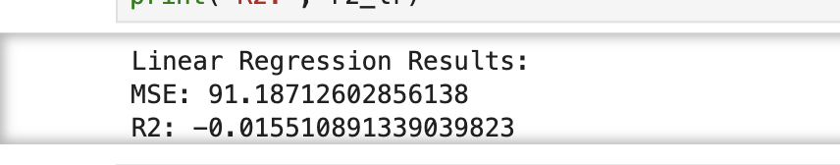

Polynomial Regression

Polynomial Regression (degree 2) was implemented to capture potential non-linear relationships between the independent variables and the target variable. By introducing squared and interaction terms, the model increases flexibility and allows for more complex patterns compared to linear regression.

However, the model produced an R² value of approximately -0.042, which is lower than the Linear Regression model. This indicates that the increased model complexity did not improve performance and instead negatively impacted prediction accuracy.

This outcome suggests that the dataset that the dataset may not really have very strong non-linear relationships. The inclusion of extra polynomial features may have just added noise and caused the model to overfit, limiting its capacity to generalize on unseen data. This points to the fact that the greater the complexity, the better the performance is not guaranteed always.

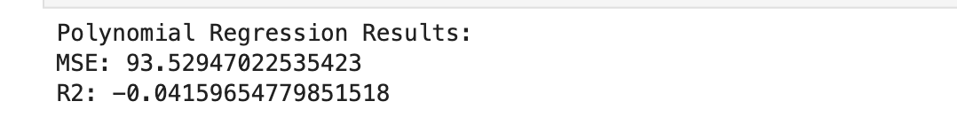

Ridge Regression

Ridge Regression was applied to address potential overfitting by introducing L2 regularization, which penalizes large coefficient values. This technique is commonly used when dealing with multicollinearity or noisy features, as it stabilizes the model and reduces variance.

The Ridge model produced an R² value of approximately -0.015, which is nearly identical to the Linear Regression model. This indicates that regularization did not significantly improve model performance.

The absence of any improvement in the situation indicates that the dataset isn't possibly affected by strong multicollinearity or overfitting issues to a great extent. The major drawback however is the insufficiently strong association between the independent variables and the target variable, i.e. regularization on its own cannot improve the prediction performance.

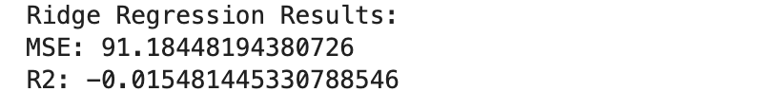

Lasso Regression

Lasso Regression was implemented using L1 regularization, which not only penalizes large coefficients but also performs feature selection by shrinking some coefficients to zero. This makes the model simpler and more interpretable by eliminating less important variables.

The Lasso model achieved the highest R² value of approximately -0.0117 among all tested models, making it the best-performing model in this analysis.

The improved performance can be attributed to Lasso's ability to eliminate irrelevant or weak predictors, so that the model is left with only the most influential features to focus on. Here, for example, variables like AttendanceRate and PreviousGrade were set to zero, which means they are not really important in predicting FinalGrade.

This goes to show that doing feature selection can lead to more stable and better performing models, particularly when the data used has weak or noisy predictors.

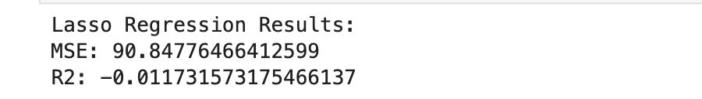

Elastic Net

Elastic Net Regression was implemented as a hybrid approach combining both L1 (Lasso) and L2 (Ridge) regularization techniques. This model aims to balance feature selection and coefficient shrinkage, making it suitable for datasets with both irrelevant features and potential multicollinearity.

The model produced an R² value slightly lower than Lasso, indicating that it did not outperform the best model. While Elastic Net provides a balanced approach, its performance suggests that combining regularization techniques did not significantly enhance predictive accuracy in this dataset.

This further confirms that the primary limitation is not related to model complexity or overfitting, but rather the lack of strong predictive relationships within the dataset.

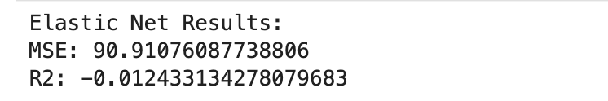

Deriving the Regression Equation the Dataset (1 point)

Deriving the Regression Equation from the Dataset
The best-performing model identified from the analysis was Lasso Regression, based on having the highest R² value among all models. Therefore, the regression equation was derived using the intercept and coefficients obtained from the Lasso model.
The regression equation is expressed as follows:

FinalGrade = 80.031 − 0.534(Gender) + 0.299(StudyHoursPerWeek) − 0.054(ExtracurricularActivities) − 0.241(ParentalSupport) + 0.178(Online Classes Taken)

In this equation, the intercept (80.031) represents the baseline prediction when all independent variables are zero. The coefficients indicate the contribution of each feature to the predicted FinalGrade. Variables such as AttendanceRate and PreviousGrade were assigned coefficients of zero, indicating that they were not significant predictors in the model. This demonstrates the feature selection capability of Lasso Regression.

Manual Substitution and Prediction
To validate the regression equation, five records were randomly selected from the dataset. The values of the independent variables were substituted into the equation to manually compute the predicted FinalGrade for each record.

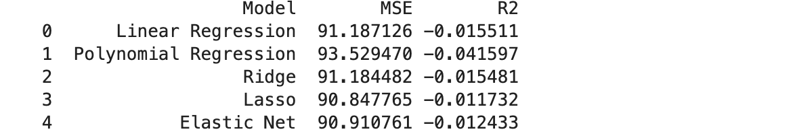

Record 1
FinalGrade =
80.031 − 0.534(0) + 0.299(10) − 0.054(0) − 0.241(1) + 0.178(1)
FinalGrade = 80.031 + 2.990 − 0.241 + 0.178
FinalGrade ≈ 82.96
Actual Value = 72

Record 2
FinalGrade =
80.031 − 0.534(0) + 0.299(10) − 0.054(1) − 0.241(3) + 0.178(0)
FinalGrade = 80.031 + 2.990 − 0.054 − 0.723
FinalGrade ≈ 82.24
Actual Value = 62

Record 3
FinalGrade =
80.031 − 0.534(0) + 0.299(22) − 0.054(1) − 0.241(1) + 0.178(1)
FinalGrade = 80.031 + 6.578 − 0.054 − 0.241 + 0.178
FinalGrade ≈ 86.49
Actual Value = 62

Record 4
FinalGrade =
80.031 − 0.534(1) + 0.299(17) − 0.054(1) − 0.241(3) + 0.178(1)
FinalGrade = 80.031 − 0.534 + 5.083 − 0.054 − 0.723 + 0.178
FinalGrade ≈ 83.98
Actual Value = 80

Record 5
FinalGrade =
80.031 − 0.534(0) + 0.299(20) − 0.054(2) − 0.241(1) + 0.178(0)
FinalGrade = 80.031 + 5.980 − 0.108 − 0.241
FinalGrade ≈ 85.66
Actual Value = 85

Record | Actual FinalGrade | Predicted FinalGrade
1 | 72 | 82.96
2 | 62 | 82.24
3 | 62 | 86.49
4 | 80 | 83.98
5 | 85 | 85.66
Note: Students are encouraged to apply models beyond those covered in the lecture slides to earn additional points. 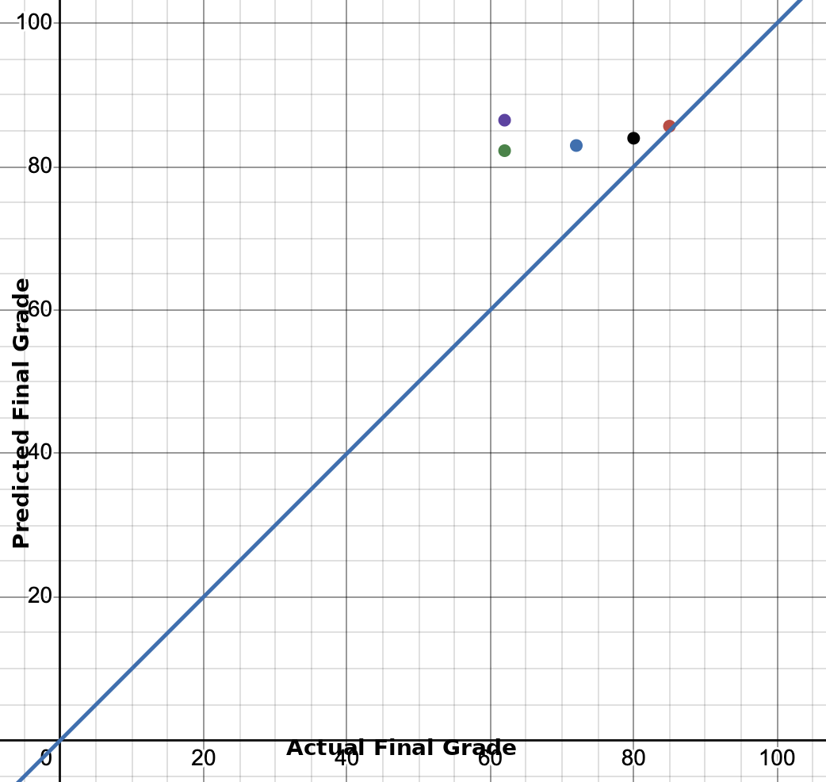

- The X-axis represents the actual FinalGrade values
- The Y-axis represents the predicted FinalGrade values
- Each of the five records was plotted as a point
- A diagonal reference line was drawn to represent perfect predictions
The plotted points show noticeable deviations from the diagonal line, indicating that the predicted values are not highly accurate.

Analysis
The comparison between actual and predicted values shows that the model tends to produce predictions within a narrow range, regardless of variation in the input data. This indicates that the model is not highly sensitive to changes in the independent variables.
This observation is consistent with the low R² values obtained earlier, confirming that the dataset lacks strong predictive features. While Lasso Regression was identified as the best model, its performance remains limited due to the weak relationships between the variables and the target.

Classification Model (8 Points)

Classifying the dataset based on the target variable (1 Point)
The dependent variable FinalGrade, which is originally a continuous numerical variable, was transformed into a categorical variable to enable classification modeling.
A criterion was defined to group student performance into three categories:
- Low: FinalGrade < 70
- Medium: 70 ≤ FinalGrade ≤ 85
- High: FinalGrade > 85
The grouping consistent with different levels of student performance has been decided by where low-performing students are those students who score below 70, average-performing students fall within the 7085 range, and high-performing students exceed 85. Turning the response variable into categorical classes allows classification algorithms such as Logistic Regression, K-Nearest Neighbors (KNN), Nave Bayes, Decision Trees, Support Vector Machines (SVM), and Random Forest to be used with data. The change enables the problem to go from predicting exact numerical values to predicting performance categories, which is more suitable for classification analysis.

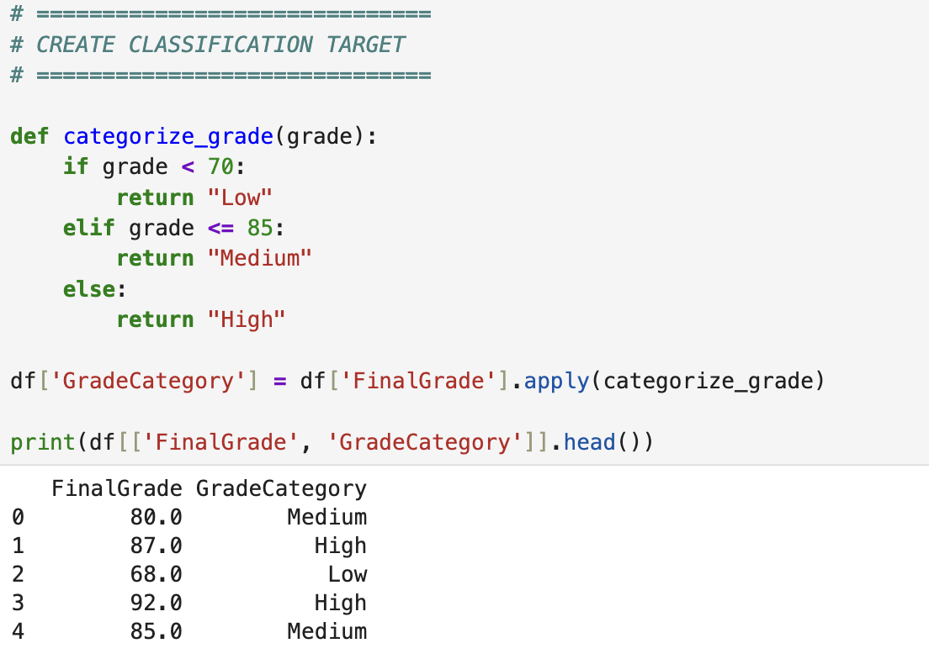

Bulding classification models (6 Points)

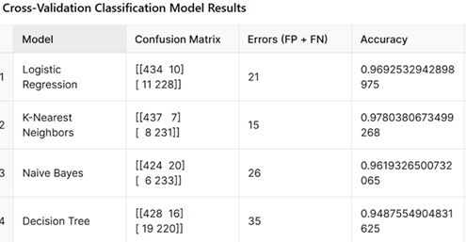

Multiple classification algorithms were implemented to categorize students into performance groups (Low, Medium, High) based on their final grades. The models applied include Logistic Regression, K-Nearest Neighbors (KNN), Naive Bayes, Decision Tree, Support Vector Machine (SVM), and Random Forest.
The dataset was first preprocessed, and a new categorical target variable (GradeCategory) was created using a defined threshold:
- Low: FinalGrade < 70
- Medium: 70 ≤ FinalGrade ≤ 85
- High: FinalGrade > 85
The dataset was then split into training (80%) and testing (20%) sets, and feature scaling was applied using StandardScaler to normalize the feature values.
Each model was trained on the training data and evaluated on the test set using performance metrics including accuracy, precision, recall, and F1-score. The results obtained are summarized below:
Model | Accuracy
Logistic Regression | 0.425
SVM | 0.420
Naive Bayes | 0.395
Random Forest | 0.370
KNN | 0.355
Decision Tree | 0.355

From the comparison, Logistic Regression achieved the highest accuracy and was therefore selected as the best-performing model.
However, it is observed that all models achieved relatively low accuracy scores. This indicates that the dataset does not exhibit strong separability between the defined classes. Additionally, some models such as Naive Bayes and SVM failed to predict certain classes entirely, leading to undefined precision values. This suggests that the features used may not be sufficient to clearly distinguish between performance categories.
Overall, Logistic Regression was chosen as the best-fit model due to its relatively higher accuracy and more stable performance across different classes.
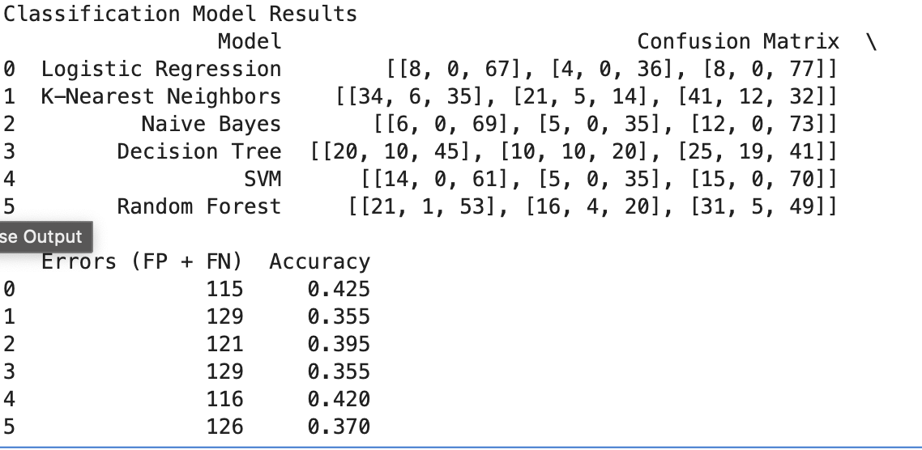

No of elements on the target variable (1 Point)

Number of Elements in Each Category Based on Best-Fit Classifier
The best-performing classifier identified was Logistic Regression. Therefore, the number of elements in each category was determined using the predicted values generated by this model.
The distribution of predicted categories is as follows:
- Low: 0
- Medium: 180
- High: 20
It is observed that the model did not forecast any samples in the Low class. This demonstrates that the model has a strong bias for the dominant class (Medium) and is not able to identify the less-performing students effectively. This weakness is most likely caused by the unbalanced classes and the lack of the features that would make the different classes more distinct in the dataset.

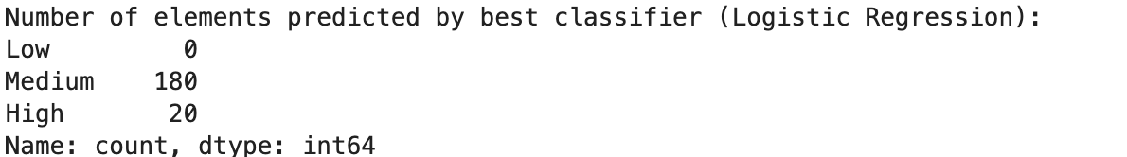

Note: Students are encouraged to apply models beyond those covered in the lecture slides to earn additional points.

Cluster Analysis (5 Points)
Building the Cluster Analysis(3 Points)

K-Means clustering was used to cluster students on the basis of academic features, which include Attendance Rate, Study Hours per Week, Previous Grade and Extracurricular Activities. Typically, the Elbow Method is used to identify the best number of clusters. A reference graph showed a bend at k = 3, so a three-cluster solution is a reasonable trade-off between simplicity and representativeness of the model. Following K-Means run at k = 3, the data points were divided into three separate clusters. For spotting the clusters, a scatter plot of Study Hours Per Week against Final Grade was employed. The plot illustrated that students' clusterings reflected their level of performance and engagement.

Traditionally: On the whole, clusters didn't diverge greatly in terms of FinalGrade because their means were quite close. Hence, segmentation principally teased out distinctions in student behaviors and engagement, rather than clear delineations of performance levels.
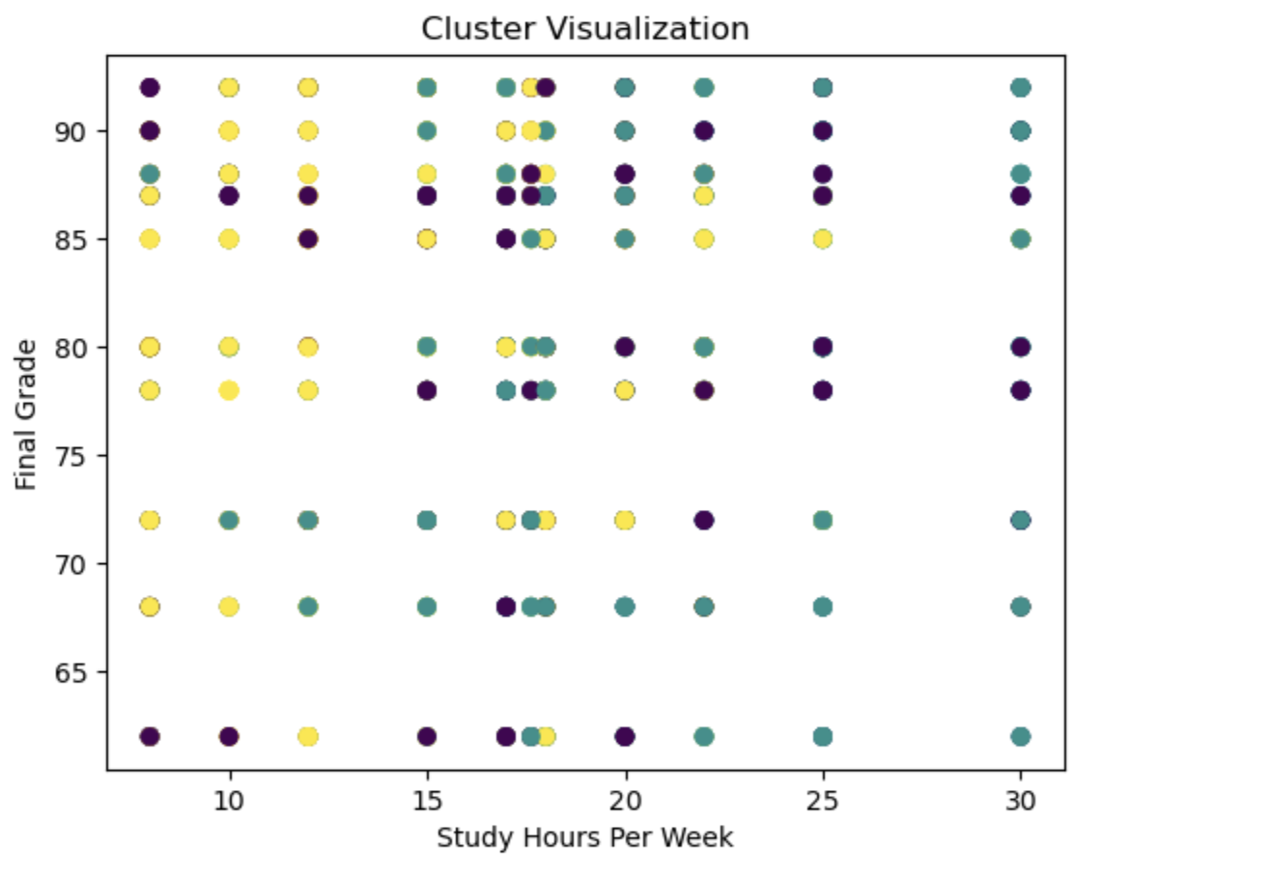

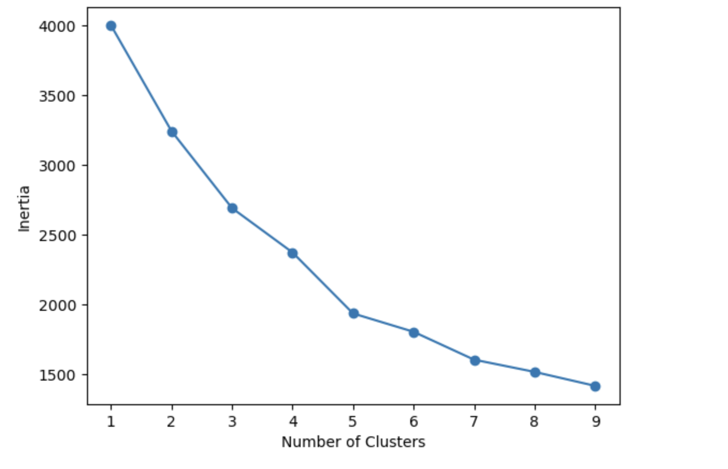

Strategy Formulation(2 Points)
Based on the clustered data, analyse each cluster and specify the strategy for each cluster.

Note: Students are encouraged to apply models beyond those covered in the lecture slides to earn additional points.

Strategy Formulation

On the grounds of the clustering outcomes, three groups were formed out of the dataset. Yet the mean FinalGrade of the clusters is almost the same (around 80), so it is not the case that the clusters represent various performance levels. Actually, clustering mainly shows the differences in study behavior and engagement patterns rather than academic outcomes.

Cluster 0 – Balanced Students
Students in this cluster show moderate study hours, average previous grades, and moderate participation in extracurricular activities.
Strategy:
Maintain consistent academic monitoring and provide general academic support. These students are stable but can benefit from structured improvement strategies such as time management and study planning.

Cluster 1 – Highly Engaged Students
Students in this cluster have higher study hours, higher previous grades, and the highest level of extracurricular participation.
Strategy:
Provide enrichment opportunities such as advanced coursework, leadership roles, and academic challenges. These students are highly active and should be encouraged to further develop their skills.

Cluster 2 – Low Engagement Students
Students in this cluster spend fewer hours studying and also have lower participation in extracurricular activities; however, their final grades are still comparable to those of students in other clusters

Strategy:
The main effort should be concentrated on increasing the level of student engagement via mentoring, motivational programs, and involvement in both academic and extracurricular activities. By raising students' participation levels, it is possible to help them keep or even improve their academic performance in the long run.

Overall, the clustering shows that students with different behaviors can achieve similar academic outcomes. This highlights the importance of understanding student engagement patterns rather than relying solely on final grades.

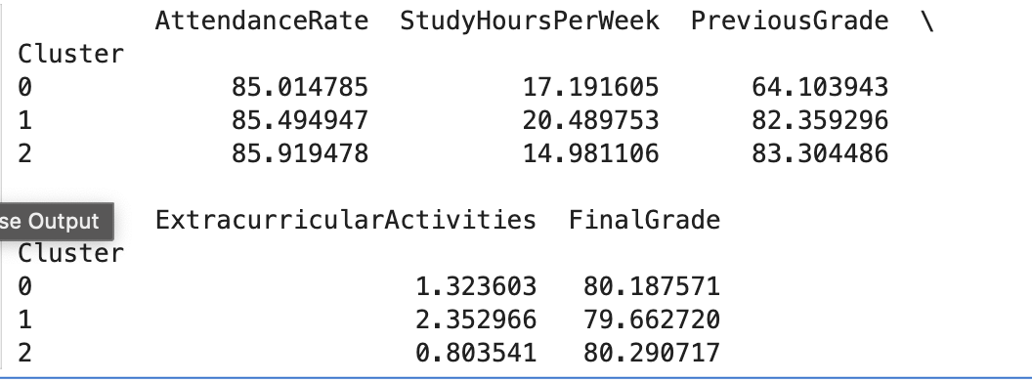

End of Documentation.

